Vice-Chancellor

APPLICATION FOR FUNDING
Reg. No.
STYR 2026/148
Date 2026-02-02
Note: This is a translation of the original application form in Swedish. The assessment of the application will be based on the original instructions in Swedish.

Application for funding for initiatives in support of equal opportunities, gender equality and preventive work against discrimination
Follow the instructions when completing the form below. Incomplete applications will not be processed. Send any questions about the application to radetjol@hr.lu.se.
Postal address Box 117, 221 00 Lund Visiting address Sandgatan 5 Telephone +46 46 222 00 00
E-mail radetjol@hr.lu.se Website https://www.staff.lu.se/organisation-and-governance/vision-objectives-and-strategies/gender-equality-and-equal-opportunities/funding-equal-opportunities-initiatives

1. Applicant details
Name of applicant (division/department/equivalent)

Faculty, department/equivalent

Name of contact person | Phone number of contact person
Email address of contact person

Co-applicants/collaborating organisations where applicable

2. General information
Title of initiative

Amount applied for (SEK) | Expected duration of initiative (from – to)
Cost centre for payment (department/equivalent), name and in figures

Background
What is the problem you want to address and how big is that problem? What is needed and why is it needed?

How does the problem relate to equal opportunities, gender equality or preventive work against discrimination?

How does it fit in with your organisation's overall work with equal opportunities, gender equality or preventive work against discrimination?

Have you checked whether a similar action is ongoing or already conducted within the university within the immediate future?

Aim and goals
Describe the aim of the initiative.

What objectives can the action contribute to in order to promote equal opportunities, gender equality or the preventive work against discrimination?

Implementation
Describe what is to be done (e.g., initiative a seminar series, a careers programme, a panel debate) and who is to do what.

Who is the initiative aimed at, who is the target group (e.g. administrative staff, faculty management, undergraduate or doctoral students)? How many people are involved?

Timetable
Describe the timetable - when does the work start, when does the initiative take place, when does it end and when is the evaluation to be carried out?

Evaluation
How is the initiative to be evaluated (e.g. written or oral evaluations) and what will the evaluation focus on?

If the outcome of the initiative can be relevant to implement in the organisation, how will the implementation be carried out?

Collaboration and support
How do you cooperate with employee organisations and/or student organisations?

How have you established supported for the initiative at the faculty/department/unit/equivalent?

Cost estimate
Below are some examples of costs. Remember to include costs for overheads (OH) and social security (employer’s contributions, LKP) for salaries and fees.

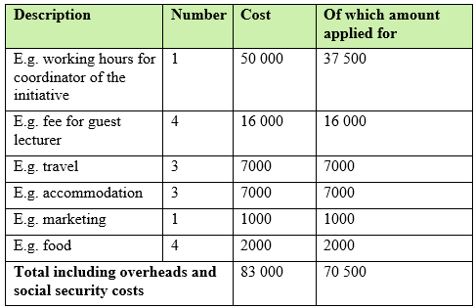

Description | Number | Cost | Of which amount applied for
Total including overheads and social security costs

Signatures
Date: | Date:
Signature of applicant/applicant’s contact person | Signature of head of department/equivalent
Name in print | Name in print

The signed or digitally signed application is sent to radetjol@hr.lu.se.
Your application must be received no later than 31st of March 2026.

Cost centre within the Lund University public authority. Students and employees are to collaborate with a department/equivalent within the Lund University public authority, which is the principal for the application and administrates the finances pursuant to Lund University regulations.

